Patient Participation Group 2019-2020

Date: 04.09.2019
Presented by: Dr Siva, Dr Steve

Health risk calculators

Reason for talking about this
Many patients are keen to understand more about the percentage risk they have been informed by GP or hospital doctors.

In the past year, the practice has, as far as possible, appended the heart attack /stroke 10-year risk score to the text message when we inform patients of high cholesterol results.

What does risk score mean
It is a way of estimating the chance of some disease occurring, usually given as a percentage.

Say, the doctor tells you have a 22% risk of heart attack/stroke in the next 10 years. That means, for 100 people with the same characteristics as yourself, 22 of them will suffer heart attack/ stroke within 10 years. You may be among the unlucky 22, or you may escape if you are one of the other 78.

It follows that the higher % risk is, the more people out of 100 will end up with disease, and the greater chance you will be among the unlucky group.

How are the risks calculated?
The first study into this subject began in 1948, in a town called Framingham in Massachusetts, USA. Researchers identified a range of conditions which make an individual more prone to heart disease. Some conditions are hereditary, others are environmental, and yet others are due to lifestyle. These came to be known as risk factors.

Over time, researchers understood that various risk factors carry different weight, and some risk factors affect other risk factors. By number crunching the data, they came up with scientific calculators to provide a personalised assessment.

What risk scores do the practice calculate?
The simplest example is the Body Mass Index (BMI). This is a crude measure, but it does underlie the risk of developing many diseases from diabetes to heart attack to cancer.

The score in the text messages we mentioned earlier is Q-Risk. This is worked out from age, gender, ethnicity, smoking status, pre-existing diabetes, family history of heart disease, pre-existing kidney impairment, irregular heart rhythm, pre-existing rheumatoid arthritis, cholesterol level, blood pressure level, height and weight.
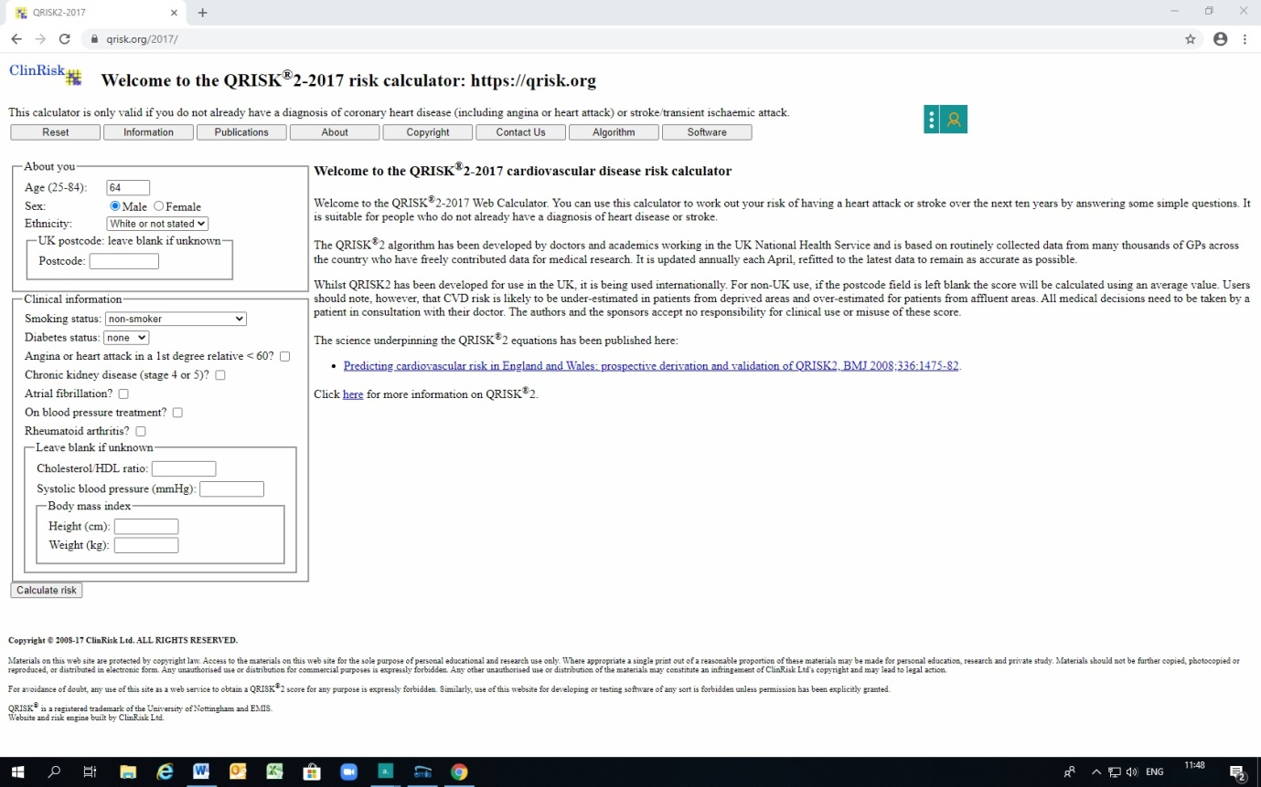

Another pair of scores used for people with known heart disease or irregular heart rhythm are CHA2DS2-VASc score to assess the risk of blood clots, and HAS-BLED score to assess the risk of bleeding. These allow clinicians to judge whether a patient should start anticoagulation (blood thinning treatment).

Does the practice calculate risk scores for everyone?
We try to assess risk with scores when we consider a patient with any one risk factor. This may be during clinical consultation, on receiving lab results, or when reviewing repeat prescriptions.

Practice population: 5,734
Blood pressure high: 553
QRisk calculate: 457 (83%)
Cholesterol high: 1,956
QRisk calculated: 1,558 (80%)
Diabetes: 417
QRisk calculated: 368 (88%)

How can I know about my risk score?
Patients who have EMIS Patient Access online can log in to check their test results.
For an update calculation, please contact the practice staff. Alternatively, many calculators are on websites which are free to access.

Thank you for your attention!

